Assignment 2: Information Architecture, Wireframe, Mood Board


Basic Information

Due Dates:
- Optional: Submit for peer review: Day 1 of Week 6
- Optional: Provide comments to two peer teams: Day 4 of Week 6
- Final due: Day 1 of Week 7

Percentage of Grade: 20%

Objectives:
- Develop Information Architecture of website.
- Create a wireframe to illustrate site layout.
- Construct a mood board that describes the styling of website.

Deliverable(s):
- Document with:
  - Parts from Assignment 1
  - Required components of Assignment 2 including information architecture, wireframe and mood board

Description
In Assignment 2, you will continue the work you have already completed for the web development project. Your goal is to build a professional, aesthetically pleasing, user-friendly, and responsive website for an organization. Now that you have an understanding of the primary users - their intent, the “why” behind it, and how they’d like to achieve their goal - you can begin to figure out how to present your content in a way that will make sense to your users. This assignment asks you to work on the content architecture and aesthetic design of the website.

Steps

- Build on Assignment 1: Use your team’s submitted document for Assignment 1: Project Plan and Needs Assessment, and update it with any required changes based on adjustments to the mission/purpose, scope, dates, other details, and any specific instructor feedback or further refinement you might want to make. In your timeline for the project plan, include a column to indicate the status of the parts completed thus far, or the portion completed. Make sure the purpose of the website is specific and written in purpose/goal format. For example, “To develop a site that provides up-to-date information on the library’s collections and new acquisitions.” Add the following sections required for Assignment 2 to the bottom of the document, and continue working. Assignment 2 has eight components. The last three components are the major deliverables for this assignment.
- Site Description: What are the simple words and phrases you want a visitor from your primary audience to use to describe the new or redesigned website that you are creating?
  - The whole searching process felt very streamlined and to-the-point.
  - The website was visually appealing and descriptive of current MOS events without being cluttered.
- Reference Websites: Identify 3-4 websites that accomplish what you’re trying to achieve in your website. Add the URL for each site. For each website, identify one thing that the site does well and why. How does this relate to the goals or design of your own website?
- Smithsonian Institute Museums: https://www.si.edu/
  - Has a carousel with upcoming events. We had discussed as a group that, no matter what, a museum needs to have a prominent events carousel.
  - Has a fully developed educational component, with a STEAM section. It differs from our site such that the Smithsonian has developed its own STEAM curriculum, whereas ours coordinates with Massachusetts public curriculum.
  - Has a local search interface - searches within the subsite: https://ssec.si.edu/ This is almost exactly what we intended for the MOS site - that our site would be a subsite of the main site, focused on educational resources.
- The Metropolitan Museum of Art (MET): https://www.metmuseum.org/
  - No carousel, but a long video as the front matter.
  - They have an educational component: https://www.metmuseum.org/learn/learning-resources Not a subsite per se, just a subfolder. This component also has an Educator persona.
  - Their search features exhibits and newspaper clippings about those exhibits. It is a site search:
<script type="text/javascript">
var pageConfig = {
searchApp: {
name: 'siteSearch',
id: 'siteSearch'
}
};


- National Gallery of Art: https://www.nga.gov/educational-resources
  - Instructions are provided for materials and warm-up questions for assignments based on the work for any parents/teachers that wish to continue education on the work. This corresponds with our goal for our website to incorporate Massachusetts public curriculums to enhance teaching opportunities for parents and teachers.
  - Drop-down menus are provided for more specific searching (i.e. who is searching, what kind of resource is being searched, what is the user’s specified grade level). This feature is similar to our goal of creating a chatbot that will help users specify via search terms which items they want to learn about.
- Use Cases: Create 2-3 use cases with a specific goal for each. Within each one, mention your sample persona and any other typical users if applicable.
- EDUCATOR: An educator needs to fulfill Massachusetts State Standards (MA STE) using expeditionary learning. They come to the mos.org site, initially just to explore the offerings. Without our site, this “browsing” would be clumsy and frustrating; our site knows exactly what they want and streamlines the process. The educator simply needs to use our semantic search to state “I am a MA 6th grade science teacher. Which STE standards can I fulfill at MOS?”, and they will be shown the proper exhibits, toolkits, and a mapping of tools to standards. The educator can also navigate our site through custom navigation.
- STUDENT: A student receives an assignment from their teacher (either a MOS-centric assignment or a general one) that requires them to prepare content, such as an essay. Entering our website, they can start with the semantic search bar, but select the student filter, and be shown exhibits and kits that will let them use museum resources. They will also be shown relevant research documents from the websites’ curated collection. Like educators, they can use the custom navigation as well.
- PARENT: A parent just wants to buy tickets for a current exhibit. They can use the semantic search bar to find something their kids would like based on their search query (e.g. “My son is into robots and space”). Our site will present the parent with exhibits and ticket options, as well as learning kits to purchase. Because they chose the parent filter in search, they will not interact with any of the STEs or the museum’s Youth Engineering Solutions..

- Metadata: Write down 8-10 search terms or metadata your primary users would use to browse or search for content in your website.
  - Museum of Science Boston educator resources
  - Youth Engineering Solutions (YES) curriculum
  - Pre-K to Grade 8 STEM curriculum
  - Massachusetts STE standards aligned lesson plans
  - Engineering design activities for kids
  - Hands-on STEM activities for teachers
  - Museum of Science field trip and exhibit alignment
  - Elementary and middle school engineering units
  - Wee Engineer early childhood STEM
  - Free K–8 STEM lesson plans Massachusetts
- For shorter search terms, users can use the following:
  - STEM curriculum
  - Museum of Science Boston
  - Engineering design
  - Educator resources
  - Youth Engineering Solutions
  - Massachusetts STE standards
  - Hands-on learning
  - Early childhood STEM
  - K–8 lesson plans
  - Field trip planning
- NOTE: Since our site will have a semantic search with an AI assistant, search terms will not be critical; they can simply enter human sentences which the search will effectively translate.

- User Scenario: Use your sample persona to create a scenario answering the following questions:
EDUCATOR:
  - Needs to fulfill curriculum requirements either from the State or from their school for STEM.
  - Semantic search, with special filters for educators. Also, the site design will lead them down one of three paths, starting from either 1) STE standards 2) Exhibits 3) Activities - each path contains the other two paths.
  - The goal with semantic search/AI is to remove any friction.
STUDENT:
  - Needs to complete a school assignment by creating materials like research essays.
  - Semantic search, with special filters for students. Students will have access to curated research articles, provided by the AI/semantic search, with links to exhibits. They will not be exposed to State standards
  - The goal with semantic search/AI is to remove any friction.
PARENT:
  - Wants to find something educational and fun for their kids
  - Semantic search, with special filters for parents/visitors, such as exhibits. The AI/semantic search will match the exhibits exactly to their child’s interests. Also provides ticket options. They will not be exposed to State standards
  - The goal with semantic search/AI is to remove any friction. Navigation controls tailor their information seeking path.
- Information Architecture: Create an Information Architecture using a piece of software of your choice (e.g. Microsoft Word drawing options, Google drawing, Bubbl.us (https://bubbl.us/), Gliffy (www.gliffy.com), Mindmeister (http://www.mindmeister.com/), Popplet (http://popplet.com/), etc. The IA should include:
  - A structure that demonstrates how pages of the site connect (and don't connect) to each other.
  - Labels for each of the sections and pages of the site. These should be the labels you plan on using in the final design. They may change but try to be as accurate as possible in the IA that you develop for this assignment.
See attached file : Information_Architecture_MOS_Ed_portal.xlsx

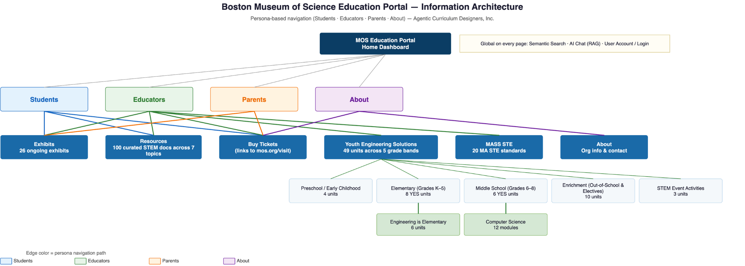
- Wireframe: Create a wireframe of the front page and one internal page for the site (making responsive mockups for tablet, smartphone is optional). The mockups should show:
  - Layout you are planning for the front page and one internal page (this should include all navigation, labels, image placement, headings, and text placement).
  - Navigation for the site - including labels that are as accurate as possible at the time you finish the assignment.
  - Placement of images on the page.
  - Location, size, and type of headings you will use on the page.
  - Placement of text on the page that shows size, type, and so on. You can use any free wireframing tool to create this.

- Mood Board:
  - Describe what images, photographs, etc. should be considered for the site. You do not need to be specific, but include general concepts for images that you will use.
    - Current and upcoming MOS exhibits.
    - STEM topics.
  - Create a mood board for your site. It should pull together your group’s ideas related to colors, fonts, images, and so on and should present an overall mood for the site via those elements. The mood of the site shouldn’t need to be explained but should be apparent from the board created. You mood board could be:
    - Dark, glossy, slick, modern, edgy, hard, aggressive.
    - Soft, muted, round, layered, elegant, realistic.
    - Colorful, rough, sketchy, bright, illustration.
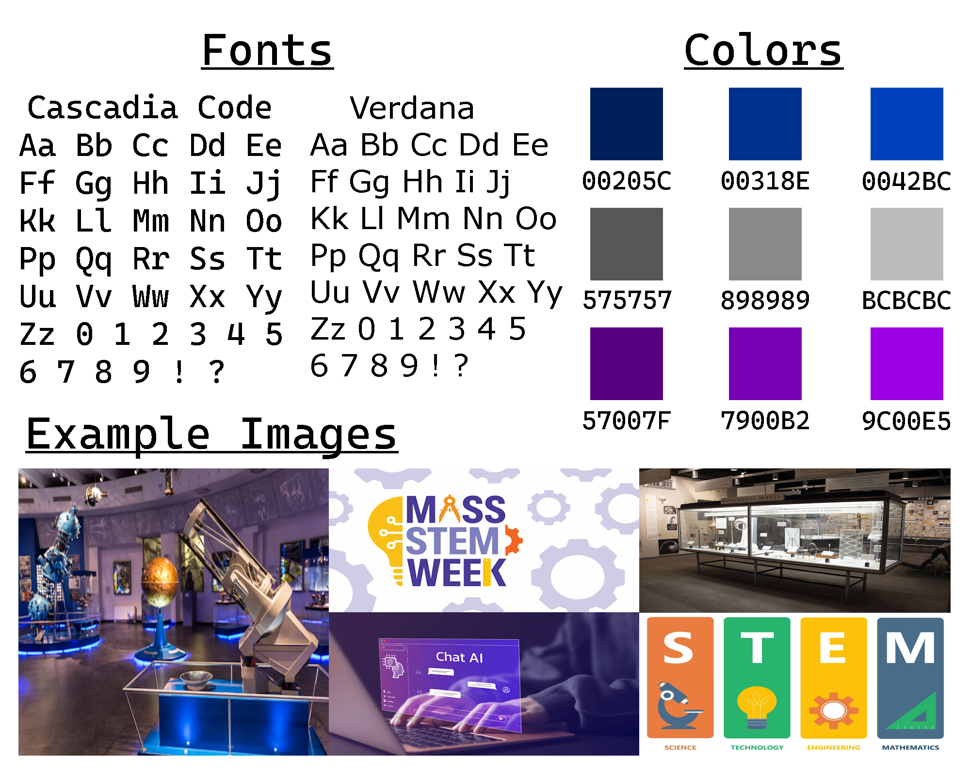

Optional: Peer review
Make sure you have completed all sections of the Google doc template (refer to sample student assignments from previous semesters). You should continue building on the same document you submitted for Assignment 1.

Optional - submit for peer review: Save your file as A2- lastname1-lastnames.pdf. Submit the PDF by clicking on ‘Peer review for Assignment 2’. Any one person in the team can submit on behalf of the team.

Optional - provide comments to two peer teams: Provide constructive feedback on at least two of your peer team submissions. Try to pick those with the least number of comments). Each member of the team can provide peer feedback to two other teams. You may use the rubrics outlined below for help.

Optional - revisions based on peer comments. Make sure that you’ve taken note of the feedback you received from your peers and made changes as appropriate. Each member of the team can record the names of the two peer team members whose assignment you evaluated and the revisions you made as a result of peer feedback.

Submission
- Teammate 1 (any one of you): Go to ‘Submission for Assignment 2: Information Architecture, Wireframe, Mood Board’, submit the final version of your document AND provide your assessment of self and peer contribution to teamwork (see below).
- All other team members: You do not need to submit the paper again, but you must also go to the submission link and follow the instructions to provide a brief assessment of self and peer contribution to teamwork.

GRADING RUBRIC
 | Unsatisfactory | Satisfactory | Excellent
Update of Assignment 1 | No updates have been made to Assignment 1, or Assignment 1 updates are inappropriate. | Necessary changes have been made to Assignment 1. | Feedback has been creatively and effectively used to update Assignment 1, both in areas that required updates and those that could benefit from updates.
Flow | Parts of assignment do not fit well together. | All or most parts of the assignment work well together. | All parts of the assignment are well integrated, and build upon one another logically and consistently.
Completeness | There are significant parts of the assignment that are missing or incomplete. | All major parts of the assignment are completed, and most details are included. | All parts of the assignment are completed thoughtfully and thoroughly.
Site Description and Reference Sites | Site description is missing, incomplete, overly complex, or inaccurate. Reference sites do not identify areas of success or are not relevant to the project. | Site description captures the basic goals of the project. Reference sites identify well executed elements of other sites that are relevant to the team’s site. | Site description is concise and highly relevant. Helps to guide the completion of the site. Reference sites identify relevant or helpful elements of other sites that will help to guide the project.
Use Cases, Metadata, and User Scenario | Use cases, metadata, and/or user scenario are incomplete, irrelevant, or not helpful. | Use cases, metadata, and user scenario are all complete and relevant. | Use cases, metadata, and user scenario are complete, thoughtful, creative, and highly relevant to the project.
Information Architecture | IA diagram is incomplete, does not demonstrate site connections, lacks labeling system or labeling system is inappropriate to the audience and purpose of the site, or diagram is missing necessary secondary navigation. | IA diagram is complete, demonstrates sites connections, labeling system is appropriate to the audience and purpose of the site, and includes necessary secondary navigation | IA diagram is complete, all site connections are extremely clear, thoughtful, and logical, and the labeling system is relevant and very helpful for the audience and the purpose of the site. All helpful secondary navigation is clearly identified.
Wireframe | Missing, necessary components are not included, placement is inappropriate, or menu items fail to capture key content. Arrangement is illogical, includes unnecessary items, or is difficult to navigate. | Wireframe includes all necessary components, placement is appropriate, and menu items capture key content. Arrangement is logical, includes only necessary items, and is easy to navigate. | Wireframe includes all components, placement is very helpful, menu items capture all key content, items are concise and streamlined, and navigation is intuitive.
Mood Board | Incomplete, unprofessional, or not cohesive. Does not capture the key essence of the website. | Mostly complete, professional, integrates elements into a cohesive mood, and captures the key essence of website. Includes all fonts, images, and colors. | Complete, cohesive experience represented for audience. All design elements are included, and are thoughtful, creative, and all work together to capture the key essence of the website.

Once you have your typical users and sample persona, you need to connect use cases with personas. Use cases provide a simple means to decide and describe the purpose of a project. Use cases have two components: actors and goals. Actors are your typical and most prominent users. Goals are what one, some, or all of the personas want to achieve. Every use case must have a specific goal and the actors that will perform tasks to achieve that goal. Goals might be things like (1) read a blog post, (2) check library account, (3) search for a book or periodical, (4) check out a book, and so on. Use cases define goals and purpose: the problems we are trying to solve.
Metadata is information about information. It’s what helps users find the content they’re looking for. Let’s say you want to search for a journal article, and go to a library website that you know should have it. If you browse around and can’t find it, it’s a sign of bad metadata. If you get your metadata right, you’ve already cleared the first hurdle of effective site design. You have to determine what kind of information to store about stuff that your primary users care about, and how to label them in ways your users can find.
To design the most pleasing experience for your users, start thinking about scenarios featuring user personas. A scenario is a story about someone (your user persona) using your website to carry out a specific task or goal, like checking out a book, looking for interlibrary loan, seeking reference help, etc. Scenarios work together with personas by serving as the stories behind why the particular persona would come to your website. you should focus on users and their tasks, rather than on your site’s organization and internal structure. As a result, you will get insights to what content the site must have and how it should be organized. here’s some more information on scenario mapping: http://www.uxforthemasses.com/scenario-mapping/
Figuring out the IA will require you to map user tasks to individual web pages. Before you even start thinking about actual design, you need to have the content in place. As Jeffrey Zeldman (@zeldman) tweeted in 2008: "Content precedes design. Design in the absence of content is not design, it's decoration." You need to decide what happens on your web pages and how many pages exist on your site. You must balance helping the users accomplish their current task while making certain the tools for what they need to do next are also available. Each page must do two things: 1) help the user accomplish one specific task; 2) make the next step easy to access. When you’re designing the site, making sure the user accomplishes each task is vitally important. However, achieving their objective usually consists of a series of small tasks, and it’s the relationship between tasks that creates the entire experience. Each page on your site needs to help build this chain of tasks. To demonstrate the pages that make up the website (that help fulfil user tasks), you will create the site information architecture. The way a site is organized, the information architecture or site map, can make or break its success. It's important to work out an information architecture plan early in the development process as that sets the flow of the content of the site.
Once you have the IA in place, you will create a wireframe. The wireframe is a visual representation or mockup of pages of the website. This visual mockup helps to take what you have developed in writing only so far into visual form. The purpose of a wireframe is to communicate the layout of a page without getting caught up in color and design elements. Wireframes can be a big time saver as they help all parties involved come to an agreement on placement of major page elements such as headers, content areas, navigation menus, and footers. The key is to get the layout nailed down so major layout changes won’t take place once detailed design elements are in place. See the free ‘wireframing tools’ listed in the ‘list of web design and development resources’ listed under ‘Course Home’ in Moodle. If you would like to use a free dummy text (Lorem Ipsum) generator for your text, you can use any of the tools in www.chooseyouripsum.com (or the ones listed in Zoterouseful resources/knowledge baseLorem Ipsum alternatives).
Mood boards (sometimes called inspiration boards) are used in a variety of disciplines. You might have seen them in interior design where fabric swatches and paint chip samples are grouped together on a poster to show a homeowner what type of atmosphere the new decor will create. They are a compilation of inspirational elements used by designers to flesh out ideas at the beginning of a design project. A mood board is extremely useful for establishing the aesthetic feel of a web site. Things that can be explored in the mood board include photography style, color palettes, typography, patterns, and the overall look and feel of the site. Soft or hard? Grungy or clean? Dark or light? A rough collage of colors, textures and pictures is all it takes to evoke a specific style or feeling. The mood board is intentionally casual; it lets the designer start with broad strokes and get feedback before too much time is invested in the wrong direction. Think of it as rapid visual prototyping. The mood board should provide a sense of the look and feel of the site you are developing.

